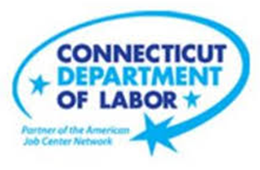

**NEW WEEKLY JOB POSTINGS FROM   
HELP WANTED ONLINE  
Office of Research**

**Week Ending May 13th, 2023: Total New Ads Down 14% Over The Week**WETHERSFIELD, May 19th, 2023 – During the week ending May 13th, 2023, there were 7,571 new postings, down 14% or   
-1,247 new ads from a week ago. Most of that overall decline occurred in three industries, Health Care & Social Assistance, Retail Trade, and Accommodation & Food Services. These three industries had a combined over-the-week decline of 908 new ads. The three employers with the largest decline over the week were Hartford Healthcare (-130 new ads), the YMCA (-77 new ads), and Burlington Stores (-70 new ads). Six industries increased over the week, with the largest gain occurring in Real Estate (+38 new ads). The graph below includes total weekly new ads for Connecticut and the United States. During the week ending May 13th, Connecticut’s total ads decline of 14% was larger than the 9% decline experienced by the United States overall. From mid-April until the first week of May, the two geographies had diverged, with the state showing gains as the nation declined. This recent weekly statewide level is the lowest since early April.  
  
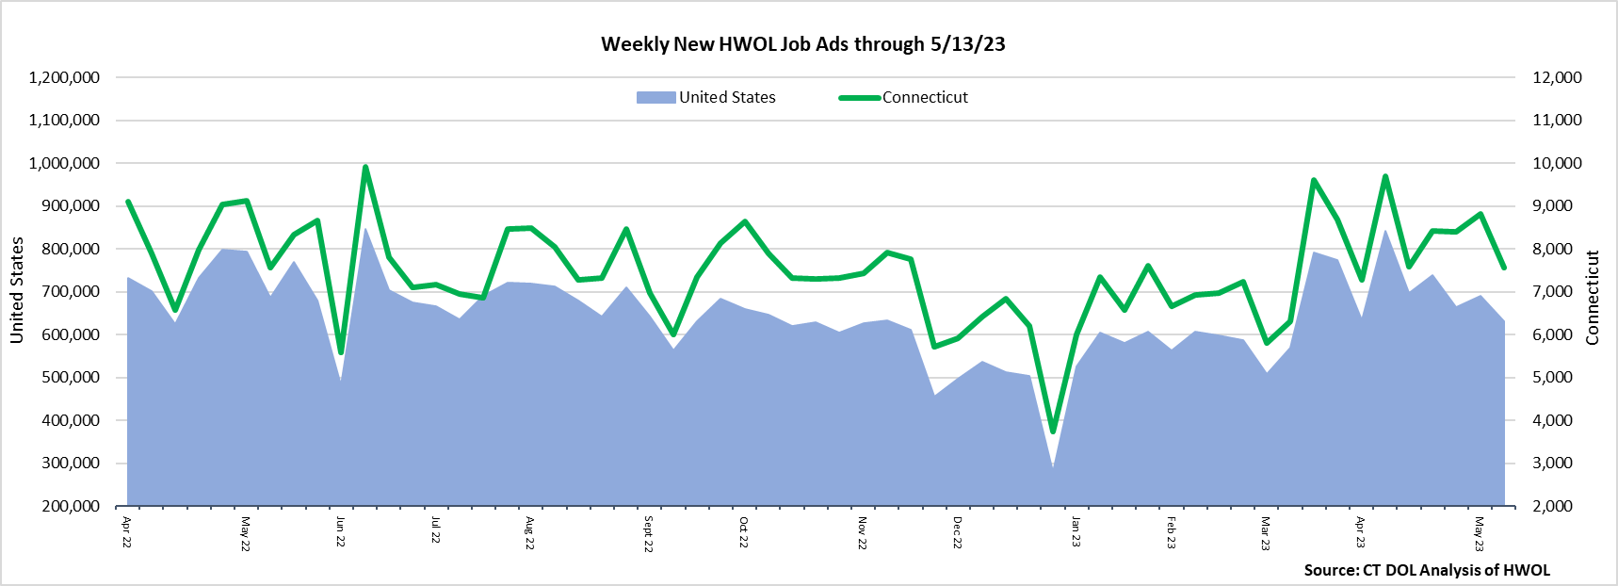  
  
**Industries** with the most new postings include Health Care & Social Assistance, Retail Trade, and Finance & Insurance.

**Occupations** with the most new postings include Registered Nurses, Retail Salespersons, and Personal Service Managers.

**Employers** with the most new postings include Yale-New Haven Health System, Hartford Healthcare, State of CT.

**The three industries with the most new job postings were:**

* **Health Care & Social Assistance** (1,780 new postings, -22% over the week)
* **Retail Trade** (699 new postings, -20% over the week)
* **Finance & Insurance** (662 new postings, -8% over the week)

   
 During the week ending May 13th, 15 industries decreased and 6 increased. The overall decrease of 1,247 new ads across all industries was driven by declines in Health Care & Social Assistance (-377 new ads), Retail Trade (-277 new ads and Accommodation & Food Services (-254 new ads). The largest employer declines in those three respective industries were Hartford Healthcare (-130 new ads), Burlington Stores (-70 new ads), and Dunkin’ Donuts (-23 new ads). Over Four weeks, total ads were largely unchanged, down 20 new ads overall or -0.3%. The largest four-week industry decline was Retail Trade (-169 new ads) and the largest increase was Health Care & Social Assistance (+136 new ads).  
  
 For more information on total job ads by industry for Connecticut and its labor market areas, see the monthly report available here: <https://www1.ctdol.state.ct.us/lmi/hwol.asp>

**New Job Postings by Occupation** 

**The occupations with the most new postings were:**

* Registered Nurses (394 new postings, -55% over the week)
* Retail Salespersons (241 new postings, -15% over the week)
* Personal Service Managers (215 new postings, +17% over the week)

**Employers with the Most New Job Postings** Employers with the most new job postings during the week ending May 13th were mostly within Health Care & Social Assistance, Finance & Insurance, and Educational Services. The employers with the most new ads in these three respective industries were Yale-New Haven Health System (192 new ads), Cigna Corporation (74 new ads), and Yale University (43 new ads). Overall, the 25 employers with the most ads account for a combined 19 percent of total new ads. Among the 25 employers shown above, 19 increased over the week and 6 decreased.   
  
**What is HWOL?**The **Conference Board Help Wanted Online**® Data Series (HWOL) measures the number of new, first-time Online job postings and jobs reposted from the previous month for over 16,000 Internet job boards, corporate boards, and smaller job sites that serve niche markets and smaller geographic areas. To view more HWOL data, go to: <https://www1.ctdol.state.ct.us/lmi/hwol.asp>